Geological Setting Reading

Bembrick, C., 2015, *The Geology of the Blue Mountains – with reference to Cox’s Road*

* Sedimentation occurring between Early Permian (295 Ma) to Middle Triassic (240 Ma)
* Western margin of the Sydney Basin developed on the broadly folded and metamorphosed sediments of the Lachlan Fold Belt, where the last stage of folding and granite intrusion occurred during the Kanimblan Orogeny, after which the area stabilised during the earliest Carboniferous (around 340 Ma)
* Period of uplift and erosion followed but highlands of moderate relief remained (evidence of mountain glaciers at high altitudes in cold climates (glacial and interglacial periods); valley glaciers and streams delivered coarse sand (~300 Ma) and subsequently (~280 Ma) sediments were deposited on a shallow, broad continental shelf in a cold water, marine environment (Shoalhaven Group Strata)

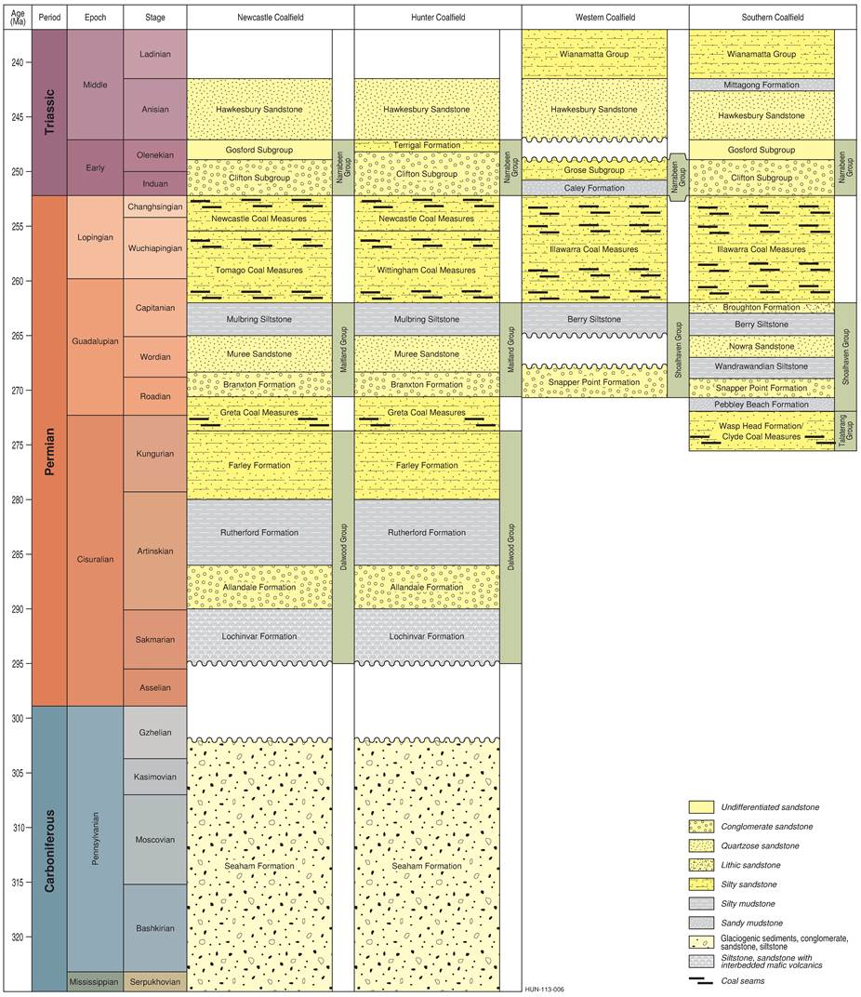

*Figure here demonstrates the stratigraphic relationship between the Shoalhaven Group and the Hawkesbury Sandstones and Wianamatta Group*

[*https://www.bioregionalassessments.gov.au/assessments/11-context-statement-sydney-basin-bioregion/1132-stratigraphy-and-rock-type*](https://www.bioregionalassessments.gov.au/assessments/11-context-statement-sydney-basin-bioregion/1132-stratigraphy-and-rock-type)

Potential Figures: Geological time scale, stratigraphic sequence of Sydney basin? See Bembrick

* Permian and Triassic (periods we are most concerned with) sequence on the western margin of the basin records the westward spread of the Permian sea and its later retreat, leading to the onset of coal swamp sedimentation. This phase of deposition ended as it was overwhelmed by coarser sediments from the north and northwest and this is dramatically evident in the bold sandstone cliff-lines of the western Blue Mountains. To the east the overlying Hawkesbury Sandstone provides evidence of the change of sediment source area as sands were derived from the south and south-west.
* Permian and Triassic sedimentation then continued for over 50 Million years as described later in this article, with major volcanic events such as the Jurassic diatremes (about 175 Ma) and the Miocene basalt flows (about 16 Ma) occurring much later in the geological history of the area.
* Blue Mountains represent the stable western margin of the Sydney Basin (Branagan, Herbert and Langford-Smith, 1976), obvious structures rare, Lapstone Monocline forms eastern boundary of the Plateau (closer to our site)
* Appears these structures have been intermittently active since the time of Permian sedimentation as borehole data indicate that the sediments thicken to the east across the structural trend
* Lapstone structure = complex of steeply west dipping reverse faults and monoclinal flexures (Herbert, 1989) – debate as to age and timing of development of this structure, but appears that much of the activity on this major structure took place in the early Tertiary
  + Proposal of timing is contentious of the uplift of this plateau
* Lapstone complex believed to be controlled by re-activation of faults in the basement rocks beneath the Sydney Basin – evidence for movement on these old structures can be seen close to the western margin of the basin

Coal measures – how relevant? Necessary in background because provide additional context?

* Hawkesbury Sandstone
  + Unit made up of medium to coarse grained quarzose sandstone with thin lenticular grey shale beds (Conaghan, 1980)
  + Large scale high angle (up to 30 deg) cross-bedding is a feature of this sandstone, crossbeds dip generally northeast indicating the source rocks for these sands were to the south west of the Sydney basin
    - This is in marked contrast to the source for most of the underlying Narrabeen Group sandstones, which were derived from the north and west.
  + Elsewhere in the basin, the shale lenses in the Hawkesbury Sandstone have yielded fish and amphibian remains, plus common plant impressions. The Hawkesbury Sandstone is considered to originate in a fluvial system on a coastal plain sloping gently northeast (Conaghan, 1980)
* Wianamatta Group
  + Confined to the lower Blue Mountains and are almost entirely represented by the Ashfield Shale
* Evidence for local glaciation is preserved in the Permian sediments of the western margin of the Sydney Basin. In late Carboniferous/early Permian times Australia (as part of Gondwana) lay much closer to the pole – probably at more than 600 south latitude. The topographic relief just to the west of the Sydney Basin margins has been estimated to be at least 600m and an environment of alpine valley style glaciations is thought to have existed at that time (Herbert, 1980).
* A study of the geology of the Blue Mountains allows us to unravel (at least partially) the events of an immense period of time, from about 300 Ma to the present. Over this period, seas have come and gone, coal swamps have thrived, massive stream systems have traversed the landscape and volcanic outpourings covered the countryside.
* Climates have changed from cold and glacial to arid and warm; water has sought to destroy the evidence written in the rocks

D. F. Branagan & H. Pedram (1990) ‘The **Lapstone structural complex**, New South Wales’, *Australian Journal of Earth Sciences*, 37:1, pp. 23-36.

* Complex consists of a number of related folds and faults, trending generally north-south – together they forma large south-plunging structure between Kurrajong Heights and Lapstone
* East-facing escarpment (Lapstone Monocline) varies: sometimes a single monocline, sometimes a double monocline and sometimes a normal or high-angle reverse fault
* main period of deformation forming the complex is believed to have taken place in the Early Tertiary, but the overall structure has a long and complex history.
* Lapstone Structural Complex younger than our cores/faults? Consists of sedimentary rocks of **Triassic** age, relicts of Tertiary gravel and minor occurences of igneous rocks (mainly dykes and necks) and Quaternary sediments **Triassic obviously applies**
* Triassic rocks + sediment
  + Hawkesbury Sandstone – major unit exposed along the complex, characteristically cross-bedded; overlain in places by Mittagoing formation (up to 6 m)
  + Mittagong Formation – consists of largely laminated siltstone; overlain occasionally by Ashfield Shale
  + Ashfield Shale – occasionally rests disconformably on the Hawkesbury Sandstone
  + Post-Triassic Sediments (gravels that reveal information about the history of tectonism)
* Igneous rocks
  + Confined to a few volcanic dykes and necks
  + Mainly basaltic and are now largely altered to clay (Biotite, Amphiboles, Pyroxenes, Olivine etc = crystallise at a high temperature and are therefore less stable at lower temperatures (Earth’s surface)
* Major structures: the Nepean Fault, South Lapstone Monocline, Mount Riverview Fault and North Lapstone Monocline
  + Napean Fault – well exposed, dominant structure south of Mulgoa – sandstone overlain by shale dips mainly easterly at 80 deg
  + South Lapstone Monocline –
  + Mount Riverview Fault - slope of the scarp remains high (up to 50°). Slab failure along the foresets in the cross- bedded Hawkesbury Sandstone is generally responsible for the slope of the scarp; has an east-side down displacement of some 200 m. As for the Nepean Fault, Herbert (1989) suggests this is a high-angle reverse fault, but his very steep structure is placed some distance west of the escarpment and his interpretation may be complicated by bifurcation of the fault
  + North Lapstone Monocline –
* Minor structures
  + those which have a limited extent (up to 50 m) in individual outcrop
  + these consist of folds, a variety of faults, joints, igneous dykes and sedimentary injection; some of these structures are believed to have formed during a period of westerly directed compression.
  + The folds have small amplitudes but comparatively high dips. The axes are parallel to the principal structures of the area and have generally been formed in the vicinity of the main structures
  + Numerous high- and low-angle normal faults, thrusts and shatter zones are present.
  + Small-scale low-angle thrust faults are common throughout the region, particularly on the Hawkes- bury Lookout Road (GR 823725), and are present within or in the vicinity of major folds or faults.
  + Overturned beds have been mentioned earlier. A tectonic origin is supported by the geophysical profiles identifying high-angle reverse faults (Herbert 1989). However in some localities overturning may have been caused by slumping.
  + Zones of intense shattering are present in massive sandstones in the old Lapstone Zig-Zag cutting
  + In summary, there were probably four periods of joint formation: one (by shearing) prior to the main eriod of deformation; two (mainly tensional) associated with that event; and a more recent period (possibly shear)
* The general north-south orientation of the major structures and many of the minor ones suggests that the major stress directions were generally the same during periods of deformation, even though there may have been change from tension to compression
* However asymmetries in the regional pattern indicate that the deformation history weren’t simple
* The Kurrajong portion of the complex is topographically nearly three times higher than the Lapstone part and the width of the disturbed area is greater in the north. Furthermore, deformation is generally greater on the eastern side.
* Broadly, the history of the complex is in three parts: (1) tectonism prior to formation of the Sydney Basin (i.e. pre-Permian); (2) movements during Sydney Basin sedimentation (Permian and Tri- assic); and (3) movements well after sedimentation ceased
* The lowest part of the Lapstone complex and the adjacent Cumberland Plain are in an area where an eastern extension of the Bathurst Batholith and the Lachlan Lineament (Scheibner 1974) would inter- sect the north-trending structure (Fig. 10). Such an intersection could well be the locus for episodic movements during and after basin sedimentation
* During the sedimentary history of the Sydney Basin there was certainly structural control of sedimentation, due to basement deformation and contemporaneous tectonism (Raggatt 1938; Branagan & Johnson 1970).
* Adjustments in the basement during the Early Triassic may have initiated the Cumberland Basin and caused the restricted area of deposition of the Mittagong Formation and the overlying Ashfield Shale (Branagan 1969; Herbert 1979). After sedimen- tation ceased, uplift possibly accentuated topographic variation by adjustment along structural weaknesses echoing those in the basement.
* weaknesses echoing those in the basement. Compressive forces continued to act from the northeast in Late Triassic times
* At some time the stress pattern changed and brittle deformation produced the major faults on both sides of the complex. A left-lateral deforming couple (i.e. west-side south) could have produced the present fault pattern, together with the flexure in the North Lapstone Monocline in the Grose Valley area, as supported by the slickenlines on faults surfaces, shatter zones and jointing at Bellbird Hill.
* Summary
  + Permian and Triassic sediments were draped over a well-developed north-trending structure intersected by easterly trending structures – an extensional event
  + Compression (mainly from the northeast) and uplift of both basement and basin sediments took place during and immediately following cessation of sedimentation – this thin-skin type adjustment formed a broad warp
  + Early Tertiary adjustments to the near-surface rocks, caused by compressional strike-slip, formed by the elements of the complex visible today
  + Later minor adjustments took place

WTC 2020 Convention: Och, D. J., Thorin, S., Graham, I. T., Nicoll., R. S., Bateman, G., 2020, *Identification of a fine ‘tuff’ lamination in the Rouse Hill Siltstone Member of the Ashfield Shale, Sydney Basin, Australia and its implications’.*

* Rock units encounteres in our project area are formations of the Wianamatta Group (especially the lower portions of the Ashfield Shale)
* Upper units (Bringelly Shale and Minchinbury Sandstone) are encountered to the southwest and western region of Sydney (out of our area of interest with the rock core we have)
* Ashfiled shale underlain by the variably thick Mittagong Formation and distinctive Hawkesbury Sanfstone
* Geologial structure
  + Sydney geology is dominated by NNE striking fault systems (Mauger et al., 1984a & b; Branagan et al., 1988; Och et al., 2009) and regional gentle folds (Herbert, 1983).
  + Stratigraphic offset due to faults is very difficult to assess across Sydney due to the relatively homogenous nature of these formations unless observed in excavations and/or compiled from mapping to define where these faults trends (Pells, et al., 2004; Och et al., 2009) occur then faults are difficult to predict.

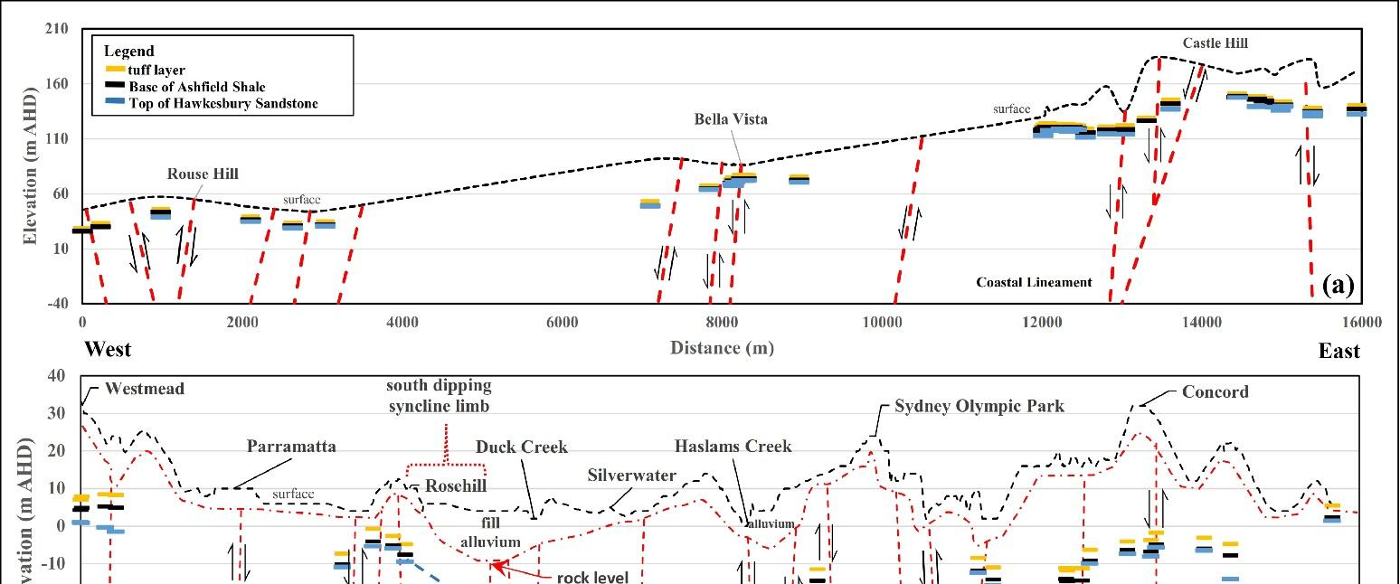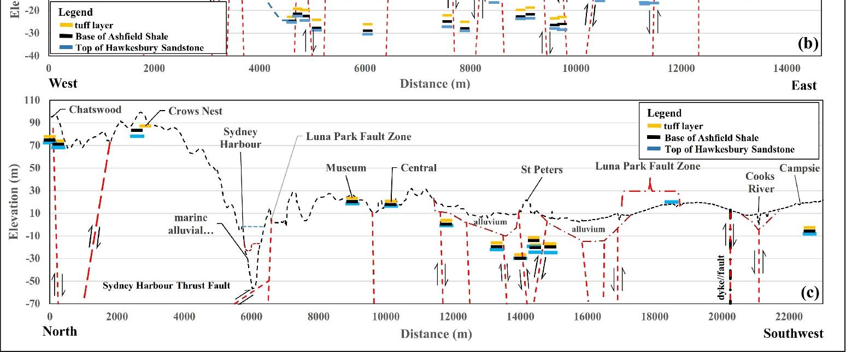

* Figure 6c shows a simplified geological section from Chatswood in the north to Campsie in the southwest illustrating considerable depth variations either side of Sydney Harbour (Figure 6c – 6000 m). The core photos assessed show the tuff lamination is mostly subhorizontal. This section is known to be intersected by major NNE fault structures (Och et al., 2009)
* Marine geotechnical and geophysical investigations (including cross-hole tomography) for Sydney Metro City & Southwest identified a low-angle thrust fault dipping to the north associated with an approximately 60 m offset (Och et al., 2017), called Sydney Harbour Thrust Fault on Figure 6c.
* The section to the south around St Peters (Figure 6c – 14000 m) is observed to have multiple offsets, suggesting a “positive flower structure” associated with the possible splaying of the dominant NNE-striking GPO and Woolloomooloo Fault Zones across this region of Sydney (Figure 1, Figure 6 – 12000 to 15000 m).
* It is observed in figure 6c that the lack of Ashfield Shale until Campsie is indicative of major regional faulting with major block elevation towards the Cooks River (Figure 6c – 17000 m to 21000 m). Evidence of this can be observed by a distinct dip to the west of bedding in the Hawkesbury Sandstone on the eastern approach to the Cooks River (Figure 6c – 20000 m to 20500 m). East of this location (Figure 6c – 20000 m) a dyke has been emplaced at a boundary between the inclined and horizontally bed sandstone indicative of block rotation due to faulting.
* Tuff lamination may be identified in the core across the central Sydney Basin is of ash-fall origin – defines a continuous layer hypothesises to be deposited from a pyroclastic eruption that ejected an extensive ash-fall cloud that was deposited across a relatively level and expansive freshwater lake system of the Sydney Basin with the eruption possible from a waning Triassic volcanic system in the adjacent north-eastern New England Orogen
* Shard-like quartz grains of volcanic origin observed
  + “Volcanic glass shards are fragments of the molten part of magma that cooled and solidified during eruption. Glass shards are typically remnants of tiny gas bubbles that developed and grew in size during the final ascent toward the surface; such shards may consist of many gas bubbles or only a portion of a single gas bubble. During eruption, the expanding gas broke the bubbles and surrounding glass into shards of various sizes and shapes. Shards formed by phreatomagmatic eruptions often have a particularly angular shape resulting from the violent explosive interaction between magma and water.”

Conclusions

* These correlations help reducing project risk by identifying faults (and offsets), which usually are associated with poor geotechnical and hydrogeological conditions.
* Findings from the preliminary assessment of more than a hundred boreholes across the Sydney region where a characteristic white lamination was identified are presented with the following conclusions:
  + The tuff lamination in the Rouse Hill Siltstone Member is a distinct lamination which is remarkably uniform
    - This white lamination contrasts greatly with the surrounding bedrock, is unique and easily differentiable from the sandstone laminations found in the overlying Kellyville Laminite Member
    - Across 106 locations where the lamination was identified, it was found to have an average thickness of 2.4 mm ± 1.5 mm and be located at 2.93 m ± 0.42 m above the base of the Ashfield Shale
    - This uniformity and continuity enables its use on infrastructure projects as a “marker horizon” (= units of the same age and of such distinctive composition and appearance, that, despite their presence in separate geographic locations, there is no doubt about their being of equivalent age and of common origin)
  + The vertical depth variations of the subhorizontal tuff lamination can be used to assess proximity to regional fault zones. Folding or faulting can be reasonably inferred if these laminations are not subhorizontal.
  + A mapping of the tuff lamination across various proposed tunnel alignments emphasises the zonal tectonic complexities in the upper rock formations of the Sydney Basin.

McMillan et al., 2019, ‘Faulting and groundwater in the Hawkesbury Sandstone: Examples from the Southern Sydney Coalfields’

* Surface outcrops of faults within the Hawkesbury Sandstone are rare compared to the number of structures identified in underlaying underground mining operations
* Hawkesbury Sandstone is highly heterogenous effecting how fault propagation occurs – these heterogeneities are the result to a depositional environment consisting of a seasonally flooding braided river system which has led to large variations in facies architecture
  + Massive to strongly bedded sandstones, laminated sandstone, siltstones and mudstones, thick overbank deposits and infilled abandoned channels
  + Products of braided river systems =
  + Effect of seasonal flooding?
* The facies types are extremely variable and inconsistent in three-dimensional space and feature a varied rock strength, which allows for a preferential path of elastic energy release during fault formation within the premise of volume conservation.
  + The resulting deformation can be observed as horizontal bedding plain separations/ rotations along weak detachment surfaces with high angled sub- vertical to vertical fracturing
* This has led to non-conventional fault / shear geometries based around channel boundaries rather than discrete fault surfaces.
* Compressional features appear to form fault propagation folds rather than distinct fault scarps. At outcrop, these features are characterised by regularly spaced fracture sets rather than the conventional damage zones and fault cores.
* In many cases these are masked by heterogeneities within the fluvial sandstone. Nonetheless, fault propagation folds form distinct connected fracture networks that, depending on factors such as stress conditions, could possibly be connected at depth.
* The increased presence of shear derived fracturing and lack of discrete unitary fault core suggests that fault / fracture zones within the Hawkesbury Sandstone will act to increase vertical hydraulic transmissivity within the fault/fold zones. A qualitative assessment of these effects on the groundwater flow is still required.

Maravelis, A. G., Catuneanu, O., Nordsvan, A., Landenberger, B., Zalillidis, A., 2016, ‘Interplay of tectonism and eustasy during the Early Permian icehouse: Southern Sydney Basin, southeast Australia,’ *UNKNOWN – WILEY?*

* Sedimentological analysis and sequence stratigraphy applied to Lower Permian sedimentary succession in the Southern Sydney Basin, Australia (South Coast)
* Varying depositional environments and sub-environments: fluvial (non-marine), marine (outer shelf) – these represent the fill of a sedimentary basin that resembles a fault-bounded rift basin
  + Deepening upward trend, these sediments can be attributed to the lowstand, transgressive and highstand system tracts
  + Lowstand sediments can be defined by fluvial facies that are located between the subaerial unconformity and the maximum regressive surface
  + Transgressive facies correspond to estuarine, upper and lower shoreface and inner and outer shelf depositional environments and are located between the maximum regressive and the maximum flooding surfaces
* The stratigraphic architecture indicates the development of an almost complete depositional sequence, mainly developed under the control of tectonically induced subsidence, but also influenced by the high sedimentation rates and the high gradient of the inherited topography. Eustatic sea‐level fluctuations were of minor importance during the deposition of the examined sediments.

Introduction

* Allogenic factors (external to depositional system) e.g. eustasy, tectonics, climate, all play a major role in relative sea-level changes, sediment supply and environmental energy
* Allogenic factors (internal to the depositional system) and are unrelated to relative sea-level changes may also play a signficiant role in stratigraphic architecture
* More stuff about sequence straigraphy, icehouse periods etc

Tectono-Stratigraphic Setting

* Sydney Basin comprises a complex system of

Czarnota, K., Roberts, G.G., White, N.J. and Fishwick, S., 2014. Spatial and temporal patterns of Australian dynamic topography from River Profile Modeling. *Journal of Geophysical Research: Solid Earth*, *119*(2), pp.1384-1424.

* Offshore, dynamic topography is relatively well constrained and can be accounted for by Australia’s translation over the mantle’s convective circulation.
* Eastern Highlands have been uplifted in two stages
  + The first stage from 120 to 80 Ma, coincided with rifting along the eastern margin and its existence is supported by thermochronological measurements
  + A second stage occurred at 80–10 Ma, formed the Great Escarpment, and coincided with Cenozoic volcanism.
* The relationship between topography, gravity anomalies, and shear wave tomographic models suggest that regional elevation is supported by temperature anomalies within the lithosphere’s thermal boundary layer. Morphology and stratigraphy of the Eastern Highlands imply that these anomalies have been coupled to the base of the plate during Australia’s northward motion over the last 70 Myr
* Australia is an important natural laboratory for studying dynamic topography, generated by an interplay between plate motion and subplate convective circulation
* Here our principal aim is to investigate how methods for extracting uplift rate histories from drainage networks can be used to constrain the onshore evolution of dynamic topography.
* landscape preservation can be attributed to successive periods of burial and exhumation rather than to prolonged exposure
* During Middle Cretaceous times, >40% of Australia was flooded by a shallow sea
* Today, the east-dipping Western Plateau is separated from the Eastern Highlands by Lake Eyre, by the Murray-Darling basin, and by the Flinders Ranges (Figure 1b). Elevation of the Western Plateau is generally < 600 m
* Maximum elevation of the Eastern Highlands rarely exceeds 1500 m with saddle elevations of 400–600 m. These highlands comprise two broad domal swells in the north and a strip of elevated topography, which follows the coastline southward.
* Distance of the drainage divide from the coast emulates the width of the adjacent continental shelf. In contrast, the Great Escarpment is located < 150 km from the coast along the whole length of the Eastern High- lands [Ollier, 1982]. Highland relief is generally low and the region is characterized by plateaux at different elevations [Bishop, 1989].
* Seismicity is generally sparse but discrete bands coincide with topographic relief in the Flinders Ranges and in the South- eastern Highlands
* Extrapolating these strain rates over the last 10 Myr indicates that < 200 m of regional uplift can be attributed to the east-west compressive stress field when flexure is considered, suggesting the landscape is predominantly sculpted by epeirogenic processes
* Southern Australia has steadily emerged from a broad region of drawdown which now coincides with the Australian-Antarctic Discordance.
* Uplift history of the Eastern Highlands is controversial - Maximum age of uplift is constrained by elevated marine Cretaceous sedimentary rocks in the north and by uplifted Triassic deltaic sequences of the Sydney Basin in the south (Figure 2a) [Wellman, 1987]. The minimum age is constrained by the vertical extent of paleochannels infilled by Cenozoic basalts [Wellman and McDougall, 1974b; Wellman, 1987]. In southeastern Australia, subaerially erupted basalts, which are ∼30 Ma, occur at an elevation of ∼30 m along the coast. Their existence implies that the erosional Great Escarpment was established by this time and that negligible uplift has subsequently occurred [Young and McDougall, 1982]. Similar observation from the Central Highlands suggests that the escarpment developed before 30 Ma with a maximum of 150 m of subsequent uplift [Young and Wray, 2000]. The uplift history between Triassic/Cretaceous and mid-Oligocene times is largely unconstrained although thermochronological data show that a significant phase of rock cooling occurred between 80 and 100 Ma [Gleadow et al., 2002; Persano et al., 2002].
* Models of the Eastern Highlands often attribute regional uplift either to faulting, to magmatic underplating, to rifting of the Tasman Sea, or to erosion of pre-existing topography
* These models assume that the crust beneath the Eastern High- lands is isostatically compensated. At the southeastern end, crustal thickness and topography do correlate, which suggests that crustal isostatic compensation is locally important - How- ever, high elevations coincide with positive long-wavelength free-air gravity anomalies and with a belt of thinner lithosphere.
* Indicate that subcrustal processes play a role in generating highland topography (Figures 2b and 2d). It is instructive to compare crustal thicknesses and elevations around the Eastern Highlands (Figure 2c). For example, at −30◦S and 152◦E, the crust is 35 km thick with an elevation of 1.4 km. At −30◦S and 149◦E, the crust is 42 km thick and 160 m high. These observations require sub-crustal density variations.
* Magmatism
  + Eastern Australia is peppered by Cenozoic volcanism, which tracks the drainage divide and supports the notion arising from the geophysical analysis that a significant thermal anomaly occurs beneath the Eastern Highlands
  + Two categories of volcanism: mafic lava fields and bimodal central volcanoes
  + The volcanoes progressively young southward and record Australia’s ∼70 km Myr−1 northward translation within a hot spot reference frame
  + lava fields have no systematic age progression. Instead, scattered eruptions occur along the length of the Eastern Highlands between ∼70 Ma and the termination of central volcano volcanism
  + equilibration temperatures and pressures from phenocrysts of Cenozoic Central Highland basalts are consistent with magma fractionation at Moho depths
  + These velocities are consistent with magmatic underplating which may have caused some of the regional uplift
* Drainage patterns
  + Longitudinal river profiles are sensitive to spatial and temporal variations in uplift
  + Given that it is mostly arid, Australia would seem to be an unlikely place to exploit this sensitivity. However, extensive temperate and wet rain forests prevailed until late Miocene times
  + In early Pleis- tocene (0.78–2.59 Ma) times, a transition to arid conditions coincided with a change from freshwater to evaporitic and gypsiferous deposition within lakes of the Western Plateau, of the Central Ranges and of the Murray Basin
* This rule-of-thumb analysis suggests that the Eastern Highlands have been affected by several uplift events. The youngest event occurs at 15–20 Ma and is visible at the northern end of the Eastern High- lands. Several distinct uplift events occur between 30 and 50 Ma. The oldest uplift event has a minimum age of 70 Ma, which is at the limit of resolution.
* On the western slopes of the southeastern highlands, paleoriver channels are preserved beneath ∼21 Ma basalt flows [Young and McDougall, 1993]. The shape and location of these paleoriver channels can be used to calibrate the four erosional constants. Despite a gap of > 20 Ma, Miocene and present-day river profiles have remarkable similar gradients (Figures 12a and 12e). This similarity of form suggests that highland land- scape evolution is dominated by headward propagation of knickzones.
* If uplift varies only as a function of time, then knickzone initiation should be the same age as, or younger than, the onset of rifting at a margin. Fault architecture within the Gippsland Basin constrains the age of rifting, which culminates in Tasman Sea floor spreading at 80–100 Ma
* These results suggest that our estimates of uplift of the Western Plateau since ∼50 Ma are robust. The pattern of uplift shows diachrone- ity from north to south. In the Flinders Ranges, increased uplift rates since ∼30 Ma are older than the inferred 10–5 Ma onset of the Australian compressional stress field, which is considered responsible for fault-controlled uplift in these ranges [Sandiford et al., 2004]. This result suggests that there might have been dynamic uplift preceding fault-related uplift.
* The northern higlands were rapidly uplifted between 120 and 100 Ma and were subsequently uplifted at a constant rate. The southeastern highlands, including New England, were uplifted in two phases. Uplift between 120 and 80 Ma was regionally distributed with decreasing amplitude toward the north. Uplift between 80 and 10 Ma becomes progressively younger from north to south and corresponds to the duration of volcanic activity
* Admittance studies and tomographic models suggest that the Eastern Highlands are dynamically supported by a thermal anomaly, which is probably located within or just beneath the thermal boundary layer of the lithosphere. This inference contrasts with other regional models, which assume that isostatic compensation occurs at the base of the crust
* Inversion of river profiles suggests that regional dynamic uplift occurred between 80 and 10 Ma when volcanism occurred along the crest of the highlands. Possible links between uplift and Cenozoic volcanism have previously been downplayed due to the inferred antiquity of the Australian landscape which was thought to be responding to isostatic rebound
* The precise uplift mechanism of the first, rift-related, uplift event remains unclear. Lister and Etheridge [1989] suggested that syn-rift uplift and mafic underplating were generated by a subplate thermal anomaly at the time of rifting. However, mapping of oceanic crustal thickness variation abutting the eastern Australian continental margin reveals an average crustal thickness of 6.4 km, which is 0.7 km thinner than the global average.
* when combined with local constraints for fluvial erosion, drainage patterns provide useful information.

van der Beek, P., Pulford, A. and Braun, J., 2001. Cenozoic landscape development in the Blue Mountains (SE Australia): lithological and tectonic controls on rifted margin morphology. *The Journal of Geology*, *109*(1), pp.35-56.

* Cenozoic landscape development on the southeastern Australian rifted margin, as recorded by mid-Tertiary basalt flows that preserve ancient landforms, is generally considered to be very slow. Eocene-Miocene basalts of the south-eastern Australian highlands flowed down paleovalleys, indicating that landscape dissection was already well under way at the time of their eruption
* The high-elevation rifted margin of southeastern Australia consists of an upland surface of low-to- medium relief known as the southeastern high- lands. It is separated from a narrow, low-elevation coastal region by a prominent escarpment
* Classical models for the evolution of the highlands followed almost exclusively “Davisian” thinking; their generally low re- lief was thought to result from peneplanation close to sea level, with Pleistocene uplift initiating the incision of valleys and landscape “rejuvenation”
* Over the last two decades, the mapping and dat- ing of widespread Cenozoic basalt remnants have provided significant new insights into the devel- opment of the highlands that h
* Have refuted their classical cyclical interpretation
* At present, the highlands are generally thought to result from regional uplift and/or base level drops related to mid- Cretaceous rifting and breakup of the Tasman Sea
* The Blue Mountains of central New South Wales (figs. 1–3) are a highlands region that developed on Permo-Triassic sediments of the Sydney Basin rather than on Paleozoic basement.
* The escarpment forming the eastern margin of the highlands contains a large embayment in the central Sydney Ba- sin, where it is located nearly 100 km inland, whereas to the north and south of the basin it lies within 30 km of the coast (fig. 1, inset). River pro- files within the Sydney Basin are graded up to a steep reach in their headwaters and appear “pinned” against the drainage divide, in contrast to rivers flowing over Paleozoic basement that are characterized by major knickpoints
* Finally, the geomorphic history preserved by basalt remnants in the Blue Mountains may differ from that else- where in the highlands. Most of the Paleocene- Miocene basalts mapped previously in the south- eastern highlands flowed down paleovalleys, indicating that river incision was already well ad- vanced at the time of their eruption (e.g., Bishop et al. 1985; Taylor et al. 1990; Young and McDougall 1993). In contrast, the Blue Mountains basalts cap relatively flat hilltops (cf. fig. 2), suggesting that they may be remnants of an initially continuous subhorizontal sheet and predate river incision (Carne 1908; Wellman 1979).
* The Blue Mountains consist of relatively flat up- land plateaus, 800–1000 m high, incised by dendritic gorges that create several hundred meters of relief (figs. 1, 2). Drainage is collected by three ma- jor rivers, the Colo, Grose, and Cox, that all flow into the Nepean River. The Nepean flows north- ward, parallel to the Blue Mountains escarpment, for ∼100 km before bending sharply eastward, be- coming the Hawkesbury River, and cutting a gorge through the low-elevation Hornsby Plateau to reach the Tasman Sea (fig. 1).
* The Blue Mountains form part of the Sydney Ba- sin (fig. 3), a Permo-Triassic foreland basin that formed during collision of the Lachlan and New England tectonic blocks (cf. Veevers et al. 1994). Maximum sediment thickness is ∼5 km at its northeastern border, where the basin is overthrust by the New England Fold Belt.
* Field Occurrence. Scattered basalt outcrops oc- cur over approximately 140 km2 within the Blue Mountains, about 70 km northwest of Sydney.
* The basalt disconformably overlies Sydney Basin sediments; the western and central outcrops occur directly on Hawkesbury or Narrabeen Group sand- stones, whereas the easternmost caps have pre- served a veneer of Wianamatta Shale. Basalt caps are generally about 50–60 m thick but reach 140 m on Mt. Tomah
* The basalt-sandstone contact is very abrupt and consists of a 1.5-m-high sand- stone cliff, suggesting that this outcrop represents a feeder pipe.
* Discussion and Conclusions
  + Although many workers have hitherto treated rifted continental margins as essentially two- dimensional structures, our study of landform ev- olution in the Blue Mountains documents impor- tant lateral variations in landform evolution on the southeastern Australian rifted margin.
  + Basalt remnants in the Blue Mountains preserve a Middle Miocene landscape of remarkably low local relief.
  + We suggest that the significant Neogene increase in relief in the Blue Mountains is controlled by the migration of major fluvial knickpoints up the river valleys toward the drainage divide where they are now pinned. Our study therefore supports previous results that suggest that knickpoint migration is a fundamental mechanism of landscape development on rifted continental margins
  + Stable regions are char- acterized by low-relief upland plateaus at around 1000 m elevation, whereas the areas of inferred Ce- nozoic uplift have much higher mean elevation and relief (van der Beek and Braun 1998). It thus seems that at least part of the lateral variation in mor- phology of the southeastern Australian rifted mar- gin may be related to localized, fault-bounded early Cenozoic uplift.
  + Denudational rebound ap- pears to drive fault reactivation on the inner margin of the highlands (Bishop and Brown 1992; Goldrick and Bishop 1995) but does not appear to be able to explain kilometer-scale localized uplift within the core of the highlands. Although a link between lo- calized uplift and the evolution of the far field stress regime seems plausible, the uplifts appear to occur along vertical dip-slip basement faults, the reacti- vation of which is not easily explained in an An- dersonian stress system (e.g., Heeremans et al. 1996). Alternatively, the timing of uplift, coeval with the onset of onshore volcanism, as well as its characteristic spacing, suggests that uplift may be related to small-scale mantle diapirism and magmatic underplating

Branagan, DF, Packham, GH, & Stewart, R 2000, *Field geology of New South Wales*, 3rd ed. (completely rev. & expanded), New South Wales Department of Mineral Resources, Sydney.

Sydney-Gunnedah-Bowen Basin

* Sydney basin major structural basin containing a thick Permian-Triassic succession
* Bounded on South and West by lower and middle Palaeozoic rocks of the Lachlan Fold Belt which are unconformably overlain by the sediments of the basin
* Permian sediments of the basin pass into the Hunter Valley (transitional area between the Sydney Basin and the New England Fold Belt)
* To the North West basin passes into the Gunnedah Basin (southern extension of the Bowen basin)
* Permian and Triassic rocks thin to the north-west and are overlain in the Bowen Basin by Jurassic sediments
* Basin extends offshore to the edge of the continental shelf
* System was initiated by rifting in the Early Permian and developed as a foreland basin in front of the deforming New England Fold Belt
* Foreland basin had a history of compression from its beginning in late Early Permian time, with the most obvious effects on the north-eastern side where the rocks of the New England Fold Belt were thrust over the basin rocks at the end of the Permian
* Effects of the compression can be recognised in the Sydney Region where minor thrust faults have disrupted Triassic rocks in places
* Towards end of Early Permian time sedimentation changed from dominantly marine to mainly non-marine coal measures deposition
* At the end of Permian time sedimentation changed to alluvial fan/fluvial environments
* After Middle Triassic time sedimentation ceased and erosion began
* Igneous activity occurred sporadically in the form of minor intrusions (alkaline intermediate-mafic) and volcanic breccia plugs in the Jurassic through the Cretaceous and Triassic (mainly olivine basalts)
  + “distinctly enriched in sodium and potassium and contain Na- and/or K-rich minerals such as feldspathoids, alkali pyroxenes, and alkali amphiboles. ... These rocks occur in continental anorogenic or within-plate tectonic settings where they are related to rifting and/or extensional tectonics”
* Faulting associated with opening of the Tasman Sea in Late Cretaceous-early Teritary (this may be outside faulting period based on what I have read – perhaps our sample with be different.. but we are not so much concerned with the age…)
* Diagram

  Description automatically generated with medium confidenceArea defined as picture to the right
* Structural centre of basin in Fairfield near Liverpool – basin is asymmetrical
* Stratigraphy
  + Deposited during Permian and Triassic time over a large area of Eastern NSW
  + Region was probably an irregular sloping surface open to the sea through much of Permian times
  + Total maximum thickness was 5 000 m, Triassic rocks 1 200 m thick
  + Complete sequence has not been found at any single locality
  + Clear evidence that earth deformation was occurring at some localities during Permian and Triassic deposition
  + Caused formation of isolated small basins and domes in some areas resulting in variation in the persistence, thickness and lithology of sediments being deposited
  + Timing contentious, Branagan and Packham think about mid-Triassic the area was uplifted to become dry land and erosion, which has continued to present time, commenced
* Permian Rocks
  + Most of the Permian units are best developed in the Hunter Valley
  + Dalwood Group and lower Shoalhaven Group, Greta Coal Measures, Maitland group, upper Shoalhaven Group, Berry Siltstone intertongues with Gerringong volcanics which have a maximum thickness of 450 metres
  + Tomago Cole measures, Newcastle Cole measures
  + roof of the uppermost coal seam in each area is taken arbitrarily as the upper limit of Permian sedimentation
* Triassic Rocks
  + Narrabeen group - these rocks crop out over a large area North and West of Sydney, but a less extensive South of Sydney,
  + South of this they underlie the massive Hawkesbury sandstone cliffs bordering the coastal plain as far as Cambewarra mountain - near Wollongong they are 250 metres thick at Cambewarra and Bundanoon they have thinned out and the Hawkesbury Sandstone rests directly on Permian rocks
  + The Narrabeen group has different characteristics- the group contains lithic and quartz sandstones, conglomerates , siltstones, olive green an reddish Brown clay stones, these last being of largely volcanic origin
  + The middle triassic hawksbury sandstone consists of lenticular overlapping beds of quartz rich sandstone, probably deposited in a large braided River system
  + lenticular layers of shale were also developed, especially North of the hawksbury River the sandstone is characterised by cross bedding which dips generally to the northeast indicating a major source of sediment to the Southwest the sandstone forms the prominent coastal cliffs between Dee Why and Wattamolla
  + The mittagong formation consists of relatively persistent thin sandstone beds up to 10 metres total thickness which occur sporadically throughout the Sydney region lying in eroded hollows of the hawksbury sandstone they are best exposed in the Michigan hilltop region but also occur in the ultimate peermont area
  + the middle triassic why anomatic group overlies the hawksbury sandstone and is divided into 3 formations these are from the bottom Ashfield shale mentioned Barry sandstone an bring galley shales
  + The Ashfield shale is the most widespread unit and contains several members which grade from siltstone to lamanite - it is well exposed on sydney's North Shore, western rail line an bankstown Liverpool area. It has a maximum thickness of 60 metres and has been extensively worked as a source of clay for bricks
* post triassic sediments
  + following off lift from about the middle of traffic time the area has been slowly eroded - the eroded material has been largely removed from the area by old rivers bracket such as the shoalhaven an hawksbury bracket and carried out to see
    - nearly 600 metres of sediment has been deposited on parts of the continental shelf North of Sydney since triassic time
  + significant thicknesses of sediment have accumulated in coastal areas such as botany Bay most of this relatively unconsolidated material preserved today in lakes and rivers is of tertiary and quarternary age earlier accumulations were probably removed during periods of increased erosion because of the absence of evidence that history of the landscape since the region became dry land is by no means clear it used to be thought that the area was reduced to lower regular plane by sometime in the tertiary
  + evidence that be tasman sea formed about 80 million years ago fits in better with the idea that the Cumberland plane was dragged down about that time disrupting old stream patterns - it may be that erosion of the region prior to that time had been balanced by uplift
  + possible humid conditions would have aided the formation of laterite soils at different times during the tertiary
    - near Sydney these laterites are developed on hawksbury sandstone, narrabeen group and why anomatic group rocks
    - the area has been affected by earth movements following the formation of laterites
* post triassic igneous activity
  + minor igneous activity is occured at a number of localities at least two periods of activity can be recognised- there are probably more
  + activity first occured in early Jurassic time possibly coinciding with uplift of sedimentary rocks
  + volcanic breccia pipes for example at Bondi are also probably Jurassic and age dolerite dykes at Bondi may range in age from Jurassic tertiary
* Sydney basin structure
  + southernmost part of the long Sydney Bowen basin structure which extends North into QLD
  + it is a sag between the Laughlin and New England fold belts
  + the basic shape of the basin developed during Permian and triassic time however it owes its present shape to late Cretaceous early tertiary earth movements that were instigated by the opening up of the tasman sea beginning about 80 million years ago (late Cretaceous)
  + this opening up cause blocks of basement rock to fault and the overlying rocks were consequently deformed to some extent perhaps largely by down dragging
  + the movement walked much of eastern Australia, as a result the present general landscape pattern was developed
  + the eastern edge of the Blue Mountains is marked by the lapstone structural complex, a zone of faults and folds that have been mapped in detail over the past 20 years
  + although faulting is not a major feature of the Sydney basin nevertheless quite complex minor faults occur many of these are strike slip and thrust faults rather than simpler normal faults

Norman, A. R., 1986, *A Structural Analysis of the Southern Hornsby Plateau, Sydney Basin, New South Wales,* University of Sydney: Department of Geology and Geophysics.